# Applied Data Science Capstone Week 5 Peer-Graded Project Report

## Introduction to the Opportunity

### Background

The City of Perth is the capital city of Western Australia. The City covers an area of 20.01 square kilometres and has an estimated population of 21,00. It’s the hub of all Mining company offices, banking, Retail, accounting, Insurance and Tourism. City of Perth is known for its high cost of living. Food not so much.

Our client came up to us to do an exploration survey for opening a new food joint. He is very open on the cuisine and wants to start small. He prefers this in an already established location as to save money on advertising. The client wants to target customers for breakfast and lunch as he does not expect much of night life in the CBD area.

## Description:

Perth is the capital city of Western Australia. It's the mining capital of the country. Its average per capita income is about $91,000. It's only second to Canberra which sits at ~$95,000. This is above the average Per Capita of Australia ~$83,000.

According to 2011 census, the main occupations of people living in Perth are 22.0% Professionals, 16.0% Technicians & trades workers, 15.2% Clerical & administrative workers, 11.4% Managers, 9.7% Community & personal service workers, 9.0% Sales workers, 8.8% Labourers, 6.5% Machinery operators & drivers, 1.4% Occupation inadequately described/ Not stated.

The people working in the Perth CBD are expected to be professionals with a Median salary of $120,000.

With this is mind we need to collect data, analyse and recommend him from the location to the cuisine he needs to succeed in Perth CBD. According to 2011 census, the main occupations of people living in Perth are 22.0% Professionals, 16.0% Technicians & trades workers, 15.2% Clerical & administrative workers, 11.4% Managers, 9.7% Community & personal service workers, 9.0% Sales workers, 8.8% Labourers, 6.5% Machinery operators & drivers, 1.4% Occupation inadequately described/ Not stated. The median age is 36 for Perth which is also the age group we want to target.

The City of Perth is famous a lot of things but not for its food. With a very high salary and a young work force we think that the market is prime for a new food joint.

1. Italian, Asian and Indian Immigrants are the highest.
2. Pizza, Pad Thai, Falafel and Butter Chicken.
3. Chinese and other Asian restaurants, sandwich joints plenty

## Data

To understand and explore we will need the following City of Perth Open Data:

1. Foursquare Developers Access to venue data: https://foursquare.com/ (<https://foursquare.com/>)
2. City of Perth Demographics (Australian Bureau of Statics, 2016)

## Methodology and Data Analysis

We have divided the data into 8 cuisine.

1. Italian
2. Indian
3. Vietnamese
4. Thai
5. KFC (Fast Food)
6. McDonalds (Fast Food)
7. Hungry Jacks (Fast Food)
8. Mexican

All steps are referenced below in the Appendix: Analysis section.

The methodology will include:

1. Loading each data set.
2. Examine the location.
3. Study the crime types and then pivot analysis of crime type frequency by neighbourhood
4. Understand correlation between the number of footfalls and the cuisine in the area.
5. Look at the density of a Cuisine in the area.
6. Make a recommendation on the
7. Determine if an area, such as the food court where the probable location of the new Restaurant should be.

Data Analysis

1. In this we load the data and explore data from Perth.
2. Transform the data of nested python dictionaries into a pandas data frame.
3. This data frame contains the geographical coordinates of Perth neighbourhoods.
4. This data will used to get Venues data from Foursquare.
5. We used geopy and folium libraries to create a map of New York city with neighbourhoods

superimposed on top.

**Food Joints visualisation-Perth City**

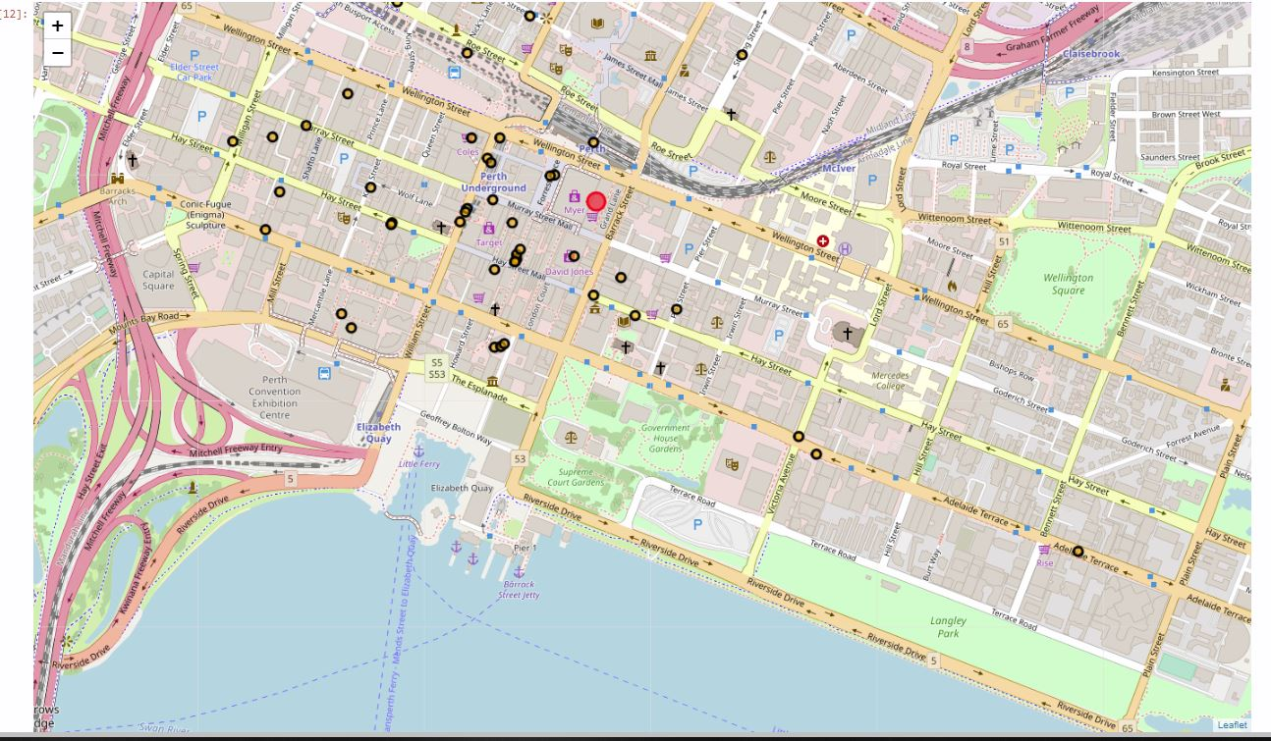

**Thai Joints visualisation-Perth City**

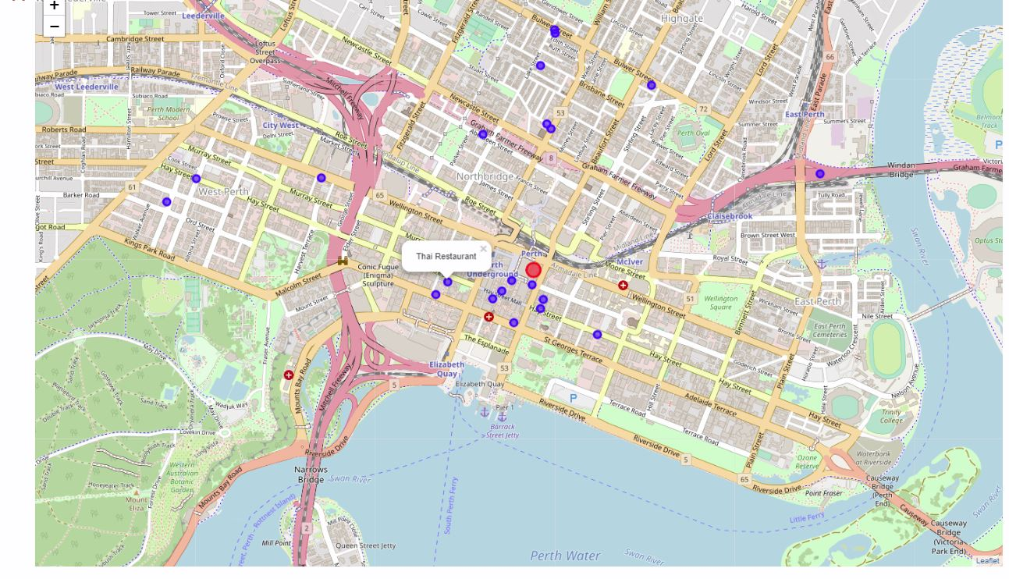

**Vietnam Food Joints visualisation-Perth City**

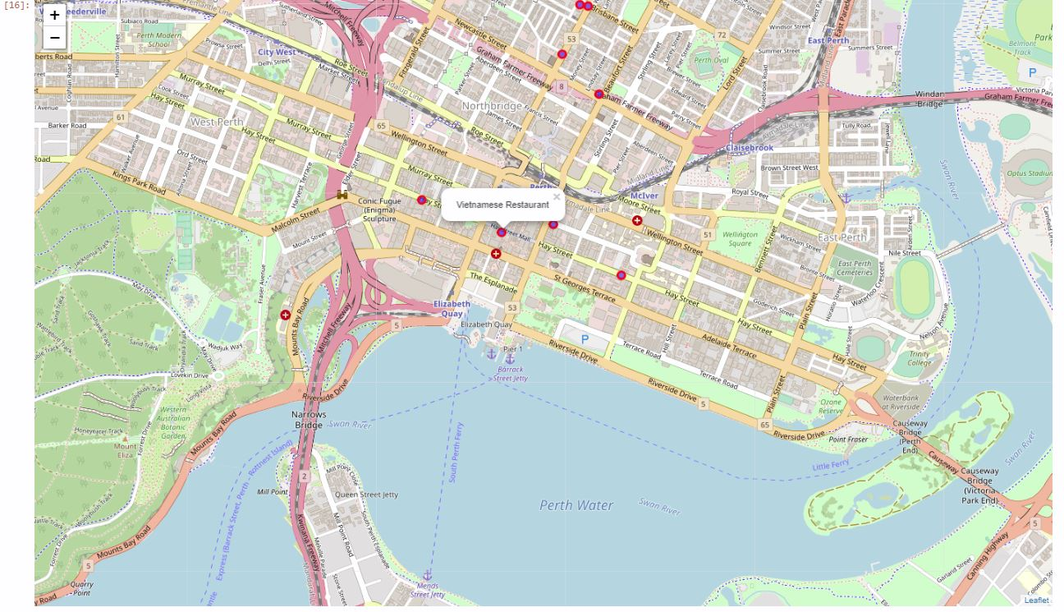

**KFC Food Joints visualisation-Perth City**

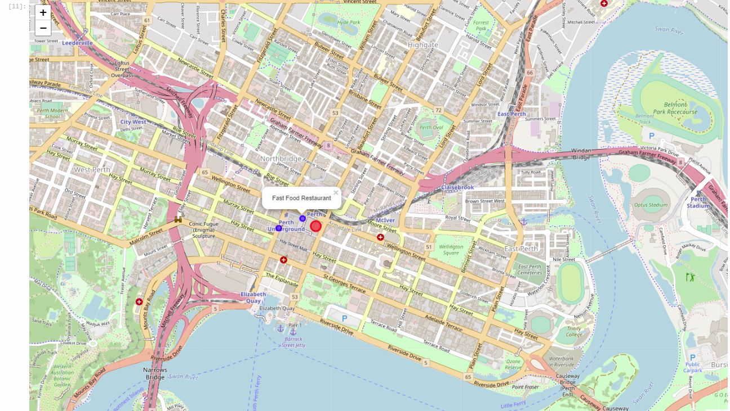

**Indian Food Joints visualisation-Perth City**

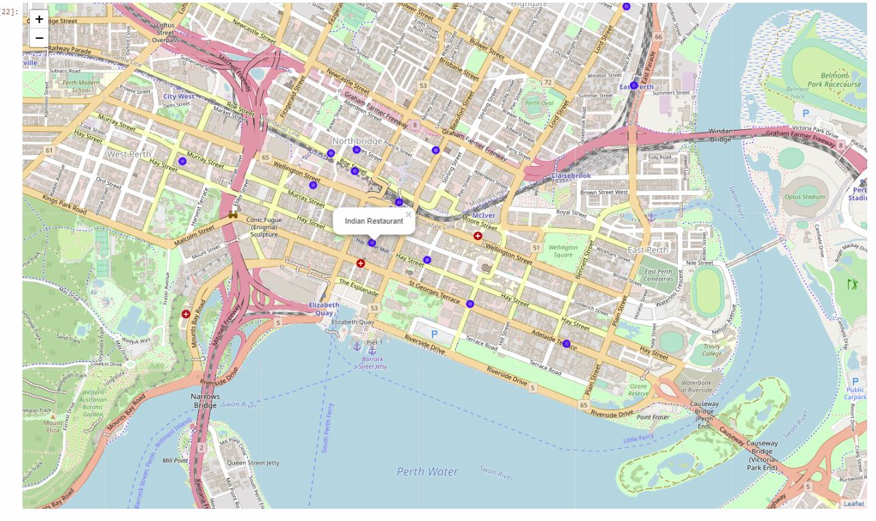**Italian Food Joints visualisation-Perth City**

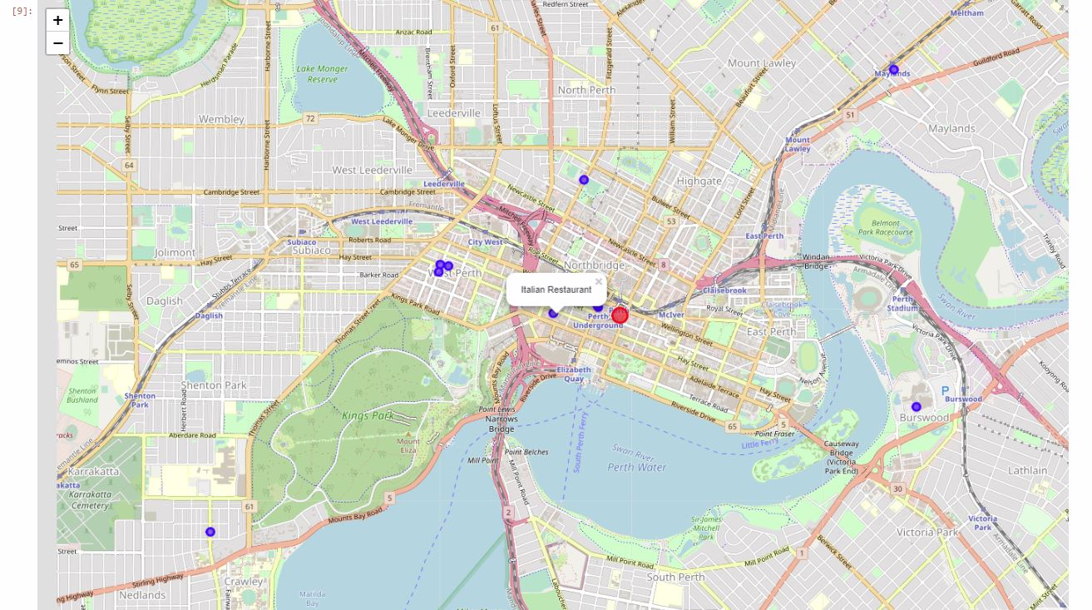

**Hungry Jacks visualisation-Perth City**

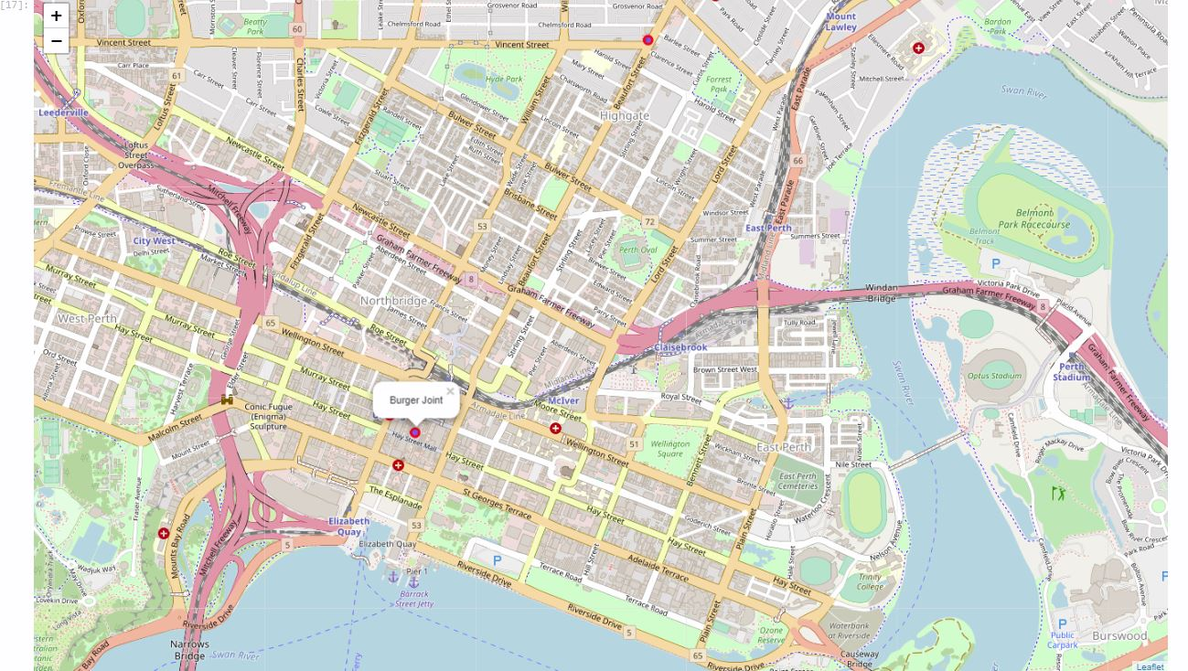

**Food Court visualisation-Perth City**

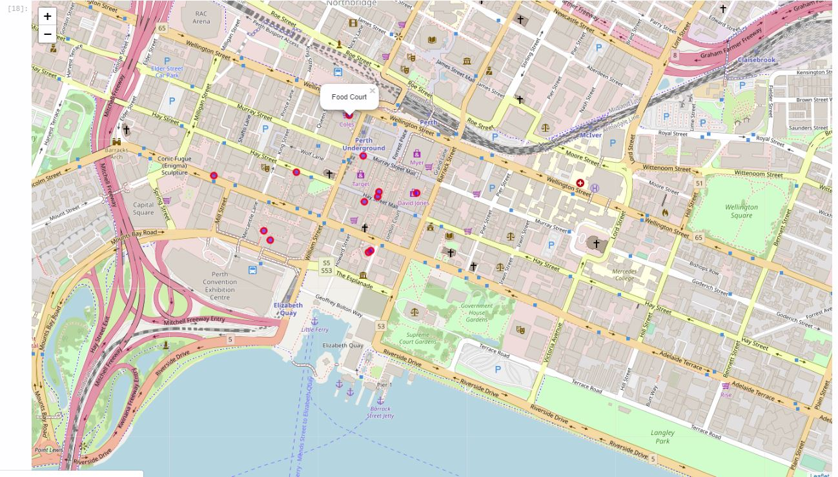

## Results

From this venues data we filtered and used only the restaurant data for Perth. As we focussed only on restaurants business.

## Discussion and Recommendations

1. There is scope for opening of a Mexican restaurant in Perth CBD.

2. The Cuisine is not adequately present in the city.

3. Mexican food through out the world has a reputation for being very spicy, but it has a wide range of flavours.

4. It is a cheap and good option to open one is Exnex 100 Foodcourt in the City of Perth.

## Conclusion

This analysis is performed on very limited data. It does not fully cover all the cuisines available in the city of Perth. The Data is limited and I cannot vouch for the authenticity of it and many liberal assumptions were made. As per Game Theory a Lot of Restaurants in one location means a lot of foot fall. With high footfall the needs for aggressive marketing comes down.

As there is an upcoming trend of Mexican cuisine coming up we would like to recommend a Mexican Restaurant. A Low risk and a competition is identified with it.

### Appendix

|  |  |  |
| --- | --- | --- |
| **Number** | **Name** | **Cuisine** |
| 1 | Thali Contemporary Indian | Indian Restaurant |
| 2 | Ganges Indian Restaurant | Indian Restaurant |
| 3 | The Indian Supermarket | Indian Restaurant |
| 4 | Indian Garden Restaurant | Indian Restaurant |
| 5 | The Indian | Indian Restaurant |
| 6 | City Heart Indian Restaurant | Indian Restaurant |
| 7 | Singapore & Malaysian Indian Cuisine | Indian Restaurant |
| 8 | Fusion 6 Indian Restaurant | Indian Restaurant |
| 9 | Dawat Nepalese & Indian Restaurant | Indian Restaurant |
| 10 | Indian Ocean Hotel | Indian Restaurant |
| 11 | Indian Restaurant | Indian Restaurant |
| 12 | Aachi Indian Cuisine | Indian Restaurant |
| 13 | Indian Ocean | Indian Restaurant |
| 14 | D'Tandoor Indian Restaurant | Indian Restaurant |
| 15 | Salt Indian Cuisine Padbury | Indian Restaurant |
| 16 | Royal Crown Indian Restaurant | Indian Restaurant |
| 17 | GoGos Madras Indian Restaurant | Indian Restaurant |
| 18 | Leederville Cafe & Indian Buffet | Indian Restaurant |
| 19 | Indian Ocean Marine Research Centre | Indian Restaurant |
| 20 | Balti | Indian Restaurant |
| 21 | Indian Express | Indian Restaurant |
| 22 | Metro Indian Restaurant | Indian Restaurant |
| 23 | Indian Express | Indian Restaurant |
| 24 | Indian Cuisine @ Cambridge Food Court | Indian Restaurant |
| 25 | Indian Ocean Drive | Indian Restaurant |
| 26 | Indian Groceries Prime Products | Indian Restaurant |
| 27 | Mirchi Masala Indian Restaurant | Indian Restaurant |
| 28 | Bollywood Spices Indian Cuisine | Indian Restaurant |
| 29 | Tasty Mo:Mo Restaurant Nepalese & Indian Cuisine | Indian Restaurant |
| 30 | Indian Curry Hut | Indian Restaurant |
| 31 | Shahi Indian Cuisine | Indian Restaurant |
| 32 | Spicy Tandoor Indian Restaurant | Indian Restaurant |
| 33 | Anokha Indian Restaurant | Indian Restaurant |
| 34 | Malwa Kitchen Indian Restaurant | Indian Restaurant |
| 35 | Bollywood Spices Indian Restuarant | Indian Restaurant |
| 36 | Golden Spice Indian Cuisine | Indian Restaurant |
| 37 | Saffron Indian Restaurant | Indian Restaurant |
| 38 | Serendib Thai And Indian Palace | Indian Restaurant |
| 39 | Indian Motorcycles | Indian Restaurant |
| 40 | Jolly Good Indian | Indian Restaurant |
| 41 | Paprika Indian Restaurant | Indian Restaurant |
| 42 | Indian Gourmet | Indian Restaurant |
| 43 | Royal Shalimar Indian Restaurant | Indian Restaurant |
| 44 | Maharaja Indian Restaurant | Indian Restaurant |
| 45 | MALABAR INDIAN CAFE & RESTAURANT | Indian Restaurant |
| 46 | Barfi Indian | Indian Restaurant |
| 47 | Malabar Indian Restaurant | Indian Restaurant |
| 48 | Bula Fijian Style Indian Cuisine | Indian Restaurant |
| 49 | Subway | Sandwich Place |
| 50 | Subway | Sandwich Place |
| 51 | Subway | Sandwich Place |
| 52 | Subway | Sandwich Place |
| 53 | Subway | Sandwich Place |
| 54 | Subway | Sandwich Place |
| 55 | Subway | Sandwich Place |
| 56 | Subway | Sandwich Place |
| 57 | Subway | Sandwich Place |
| 58 | Subway | Sandwich Place |
| 59 | Subway | Sandwich Place |
| 60 | Subway | Sandwich Place |
| 61 | Subway | Sandwich Place |
| 62 | Subway | Sandwich Place |
| 63 | Subway | Sandwich Place |
| 64 | Subway | Sandwich Place |
| 65 | Subway | Sandwich Place |
| 66 | Subway | Sandwich Place |
| 67 | Subway | Sandwich Place |
| 68 | Subway | Sandwich Place |
| 69 | Subway | Sandwich Place |
| 70 | Subway DC | Sandwich Place |
| 71 | Subway | Sandwich Place |
| 72 | Subway | Sandwich Place |
| 73 | Subway | Sandwich Place |
| 74 | Subway | Sandwich Place |
| 75 | Subway | Sandwich Place |
| 76 | Subway | Sandwich Place |
| 77 | Subway | Sandwich Place |
| 78 | Subway | Sandwich Place |
| 79 | Subway | Sandwich Place |
| 80 | Subway | Sandwich Place |
| 81 | Subway | Sandwich Place |
| 82 | Subway | Sandwich Place |
| 83 | Subway | Sandwich Place |
| 84 | Subway | Sandwich Place |
| 85 | Subway | Sandwich Place |
| 86 | Subway | Sandwich Place |
| 87 | Subway | Sandwich Place |
| 88 | Subway | Sandwich Place |
| 89 | Subway | Sandwich Place |
| 90 | Subway | Sandwich Place |
| 91 | Subway | Sandwich Place |
| 92 | Subway | Sandwich Place |
| 93 | Subway | Sandwich Place |
| 94 | Subway | Sandwich Place |
| 95 | Subway | Sandwich Place |
| 96 | Subway | Sandwich Place |
| 97 | Subway | Sandwich Place |
| 98 | McDonald's | Fast Food Restaurant |
| 99 | McDonald's | Fast Food Restaurant |
| 100 | McDonald's | Fast Food Restaurant |
| 101 | McDonald's | Fast Food Restaurant |
| 102 | McDonald's | Fast Food Restaurant |
| 103 | McDonald's | Fast Food Restaurant |
| 104 | McDonald's | Fast Food Restaurant |
| 105 | McDonald's | Fast Food Restaurant |
| 106 | McDonald's | Fast Food Restaurant |
| 107 | McDonald's | Fast Food Restaurant |
| 108 | McDonald's | Fast Food Restaurant |
| 109 | McDonald's | Fast Food Restaurant |
| 110 | McDonald's | Fast Food Restaurant |
| 111 | McDonald's | Fast Food Restaurant |
| 112 | McDonald's | Fast Food Restaurant |
| 113 | McDonald's | Fast Food Restaurant |
| 114 | McDonald's | Fast Food Restaurant |
| 115 | McDonald's | Fast Food Restaurant |
| 116 | McDonald's | Fast Food Restaurant |
| 117 | McDonald's | Fast Food Restaurant |
| 118 | McDonald's | Fast Food Restaurant |
| 119 | McDonald's | Fast Food Restaurant |
| 120 | McDonald's | Fast Food Restaurant |
| 121 | McDonald's | Fast Food Restaurant |
| 122 | McDonald's | Fast Food Restaurant |
| 123 | McDonald's | Fast Food Restaurant |
| 124 | McDonald's | Fast Food Restaurant |
| 125 | McDonald's | Fast Food Restaurant |
| 126 | McDonald's | Fast Food Restaurant |
| 127 | McDonald's | Fast Food Restaurant |
| 128 | McDonald's | Fast Food Restaurant |
| 129 | McDonald's | Fast Food Restaurant |
| 130 | McDonald's | Fast Food Restaurant |
| 131 | McDonald's | Fast Food Restaurant |
| 132 | McDonald's | Fast Food Restaurant |
| 133 | McDonald's | Fast Food Restaurant |
| 134 | McDonald's | Fast Food Restaurant |
| 135 | McDonald's | Fast Food Restaurant |
| 136 | McDonald's | Fast Food Restaurant |
| 137 | McDonald's | Fast Food Restaurant |
| 138 | McDonald's | Fast Food Restaurant |
| 139 | McDonald's | Fast Food Restaurant |
| 140 | McDonald's | Fast Food Restaurant |
| 141 | McDonald's | Fast Food Restaurant |
| 142 | McDonald's | Fast Food Restaurant |
| 143 | McDonald's | Fast Food Restaurant |
| 144 | McDonald's | Fast Food Restaurant |
| 145 | McDonald's | Fast Food Restaurant |
| 146 | McDonald's | Fast Food Restaurant |
| 147 | McDonald's | Fast Food Restaurant |
| 148 | KFC | Fast Food Restaurant |
| 149 | KFC | Fast Food Restaurant |
| 150 | KFC | Fast Food Restaurant |
| 151 | KFC | Fast Food Restaurant |
| 152 | KFC | Fast Food Restaurant |
| 153 | KFC | Fast Food Restaurant |
| 154 | KFC | Fast Food Restaurant |
| 155 | KFC | Fast Food Restaurant |
| 156 | KFC | Fast Food Restaurant |
| 157 | KFC | Fast Food Restaurant |
| 158 | KFC | Fast Food Restaurant |
| 159 | KFC | Fast Food Restaurant |
| 160 | KFC | Fast Food Restaurant |
| 161 | KFC | Fast Food Restaurant |
| 162 | KFC | Fried Chicken Joint |
| 163 | KFC | Fast Food Restaurant |
| 164 | KFC | Fast Food Restaurant |
| 165 | KFC | Fast Food Restaurant |
| 166 | KFC | Fast Food Restaurant |
| 167 | KFC | Fried Chicken Joint |
| 168 | Hungry Jack's | Burger Joint |
| 169 | Hungry Jack's | Burger Joint |
| 170 | Hungry Jack's | Burger Joint |
| 171 | Hungry Jack's | Burger Joint |
| 172 | Hungry Jack's | Burger Joint |
| 173 | Hungry Jack's | Burger Joint |
| 174 | Hungry Jack's | Burger Joint |
| 175 | Hungry Jack's | Burger Joint |
| 176 | Hungry Jacks | Burger Joint |
| 177 | Hungry Jack's | Burger Joint |
| 178 | Hungry Jack's | Burger Joint |
| 179 | Hungry Jack's | Burger Joint |
| 180 | Hungry Jack's | Burger Joint |
| 181 | Hungry Jack's | Burger Joint |
| 182 | Hungry Jack's | Burger Joint |
| 183 | Hungry Jacks | Burger Joint |
| 184 | Hungry Jack's | Burger Joint |
| 185 | Hungry Jack's | Burger Joint |
| 186 | Hungry Jack's | Burger Joint |
| 187 | Hungry Jack's | Burger Joint |
| 188 | Hungry Jack's | Burger Joint |
| 189 | Hungry Jacks | Burger Joint |
| 190 | Hungry Jack's | Burger Joint |
| 191 | Hungry Jacks | Burger Joint |
| 192 | Hungry Jack's | Burger Joint |
| 193 | Hungry Jack's | Burger Joint |
| 194 | Hungry Jack's | Burger Joint |
| 195 | Hungry Jacks | Burger Joint |
| 196 | Hungry Jack's | Burger Joint |
| 197 | Hungry Jack's | Burger Joint |
| 198 | Hungry Jacks | Burger Joint |
| 199 | Hungry Jack's | Burger Joint |
| 200 | Hungry Jack's | Burger Joint |
| 201 | Hungry Jack's | Burger Joint |
| 202 | Hungry Jack's | Burger Joint |
| 203 | Hungry Jacks | Burger Joint |
| 204 | Hungry Jack's | Burger Joint |
| 205 | Hungry Jack's | Burger Joint |
| 206 | Hungry Jacks | Burger Joint |
| 207 | Hungry Jacks | Burger Joint |
| 208 | Hungry Jack's | Burger Joint |
| 209 | Hungry Jack's | Burger Joint |
| 210 | Hungry Jack's | Burger Joint |
| 211 | Hungry Jack's | Burger Joint |
| 212 | Hungry Jacks | Burger Joint |
| 213 | Hungry Jack's | Burger Joint |
| 214 | Hungry Jacks | Burger Joint |
| 215 | Hungry Jack's | Burger Joint |
| 216 | Hungry Jack's | Burger Joint |
| 217 | Hungry Jack's Mirrabooka | Burger Joint |
| 218 | Pancho's Mexican Villa | Mexican Restaurant |
| 219 | MIX Korean with a Mexican twist | Mexican Restaurant |
| 220 | Ole Mexican & Pasta | Mexican Restaurant |
| 221 | Zapatas Mexican Restaurant | Mexican Restaurant |
| 222 | Sante Fe Mexican Restaurant | Mexican Restaurant |
| 223 | Pancho's Mexican Villa | Mexican Restaurant |
| 224 | Mexican Kitchen | Mexican Restaurant |
| 225 | Santa Fe - Restaurant and Tequila Lounge | Mexican Restaurant |
| 226 | Two Gringos Mexican Grill | Mexican Restaurant |
| 227 | Salsa's Fresh Mex Grill | Mexican Restaurant |
| 228 | Garcia's Mexican Restaurant | Mexican Restaurant |
| 229 | ZÃ³calo Mexican Restaurant | Mexican Restaurant |
| 230 | Arriba Mexicana | Mexican Restaurant |
| 231 | El Mexicano | Mexican Restaurant |
| 232 | El Mexicano | Mexican Restaurant |
| 233 | Mexican Restaurant | Mexican Restaurant |
| 234 | Outlaws Mexican Restaurant | Mexican Restaurant |
| 235 | Funky Mexican Cantina | Mexican Restaurant |
| 236 | Jamie's Italian | Italian Restaurant |
| 237 | The Italian Corner | Italian Restaurant |
| 238 | Simple Italian Cucina & Pizzeria | Italian Restaurant |
| 239 | Jamie's Italian Perth | Italian Restaurant |
| 240 | Simple Italian | Italian Restaurant |
| 241 | The Italian Club | Italian Restaurant |
| 242 | Italian Consulate Of Perth | Italian Restaurant |
| 243 | Italian Club | Italian Restaurant |
| 244 | Villa D'este | Italian Restaurant |
| 245 | Sebastian's Italian Cafe | Italian Restaurant |
| 246 | Gucce Italian Rest | Italian Restaurant |
| 247 | Italians | Italian Restaurant |
| 248 | Antonio's Italian | Italian Restaurant |
| 249 | Mangia Italiano | Italian Restaurant |
| 250 | Italian Club | Italian Restaurant |
| 251 | Modo Mio Cucina Italiana | Italian Restaurant |
| 252 | Leo's Pizza | Italian Restaurant |
| 253 | Roman Palace Italian Restaurant | Italian Restaurant |
| 254 | Lambretta Cucina Italiana Restaurant | Italian Restaurant |
| 255 | Italian Family Restaurant | Italian Restaurant |
| 256 | claudio's Gourmet Italian Pizza | Italian Restaurant |
| 257 | Raffaele's Classic Italian Restaurant | Italian Restaurant |
| 258 | Campari Italian Restaurant | Italian Restaurant |
| 259 | Tom's Italian | Italian Restaurant |
| 260 | Crena's Italian Cafe | Italian Restaurant |
| 261 | Mambo Italiano | Italian Restaurant |
| 262 | Ciao Italiano Restaurant | Italian Restaurant |
| 263 | Andiamo Italiano | Italian Restaurant |
| 264 | Swan Italian Club | Italian Restaurant |
| 265 | Zacc's Italian Restaurant | Italian Restaurant |
| 266 | Enrico Italian Restaurant | Italian Restaurant |
| 267 | Eight Slices Italian Kitchen | Italian Restaurant |
| 268 | La Vita Italian Restaurant & Wood Fired Pizza | Italian Restaurant |
| 269 | Fremantle Italian Club | Italian Restaurant |
| 270 | The Italian Job | Italian Restaurant |
| 271 | Something Italian | Italian Restaurant |
| 272 | Fusion Indo Italian | Italian Restaurant |
| 273 | Fusions Indo Italian Restaurant & Bar | Italian Restaurant |
| 274 | Italian Restaurant & Pizza Bar | Italian Restaurant |
| 275 | Carillon Food Court | Food Court |
| 276 | ENEX Food Court | Food Court |
| 277 | Raine Square Food Court | Food Court |
| 278 | 160 Central Foodcourt | Food Court |
| 279 | One40william Food Court | Food Court |
| 280 | The Food Court at Crown | Food Court |
| 281 | David Jones Food Court | Food Court |
| 282 | Westcentre Arcade Foodcourt | Food Court |
| 283 | Food Court | Food Court |
| 284 | Carousel Food Court | Food Court |
| 285 | Food Court | Food Court |
| 286 | The Underground Food Court | Food Court |
| 287 | Cafe Court | Food Court |
| 288 | Allendale Food Court | Food Court |
| 289 | Brookfield Place food court | Food Court |
| 290 | The Verandah Food Court | Food Court |
| 291 | Cambridge Forum International Food Court | Food Court |
| 292 | Food Court | Food Court |
| 293 | Mixed Food court (next door to Anz) | Food Court |
| 294 | McDonald's | Food Court |
| 295 | Central Cafe | Food Court |
| 296 | Food Court | Food Court |
| 297 | Kingsway Foodcourt | Food Court |
| 298 | IKEA Restaurant | Food Court |
| 299 | Cockburn Gateway Food Court | Food Court |
| 300 | McDonald's | Food Court |
| 301 | Belmont Forum Food Court | Food Court |
| 302 | Indian Cuisine @ Cambridge Food Court | Food Court |
| 303 | International Food Court | Food Court |
| 304 | Garden City Food Court | Food Court |
| 305 | Food Court @ E Shed Markets | Food Court |
| 306 | Karrinyup Food Court | Food Court |
| 307 | Southlands Food Court | Food Court |
| 308 | Southlands Boulevard Food Court | Food Court |
| 309 | Canningvale Food Court | Food Court |
| 310 | Food Court - Rockingham Shopping Centre | Food Court |
| 311 | Spencer Village Food Court | Food Court |
| 312 | Pheonix Food Court | Food Court |
| 313 | Armadale Food Court | Food Court |
| 314 | Food Court | Food Court |
| 315 | Forum Food Court | Food Court |
| 316 | Carillon Food Court | Food Court |
| 317 | Tra Vinh Vietnamese | Vietnamese Restaurant |
| 318 | Okay Vietnamese Restaurant | Vietnamese Restaurant |
| 319 | Nonla Vietnamese Restaurant | Vietnamese Restaurant |
| 320 | East Cafe and Vietnamese Bistro | Vietnamese Restaurant |
| 321 | Phi Yen Vietnamese | Vietnamese Restaurant |
| 322 | Saigon Vietnamese & Asian Food | Vietnamese Restaurant |
| 323 | Toto Vietnamese Restaurant | Vietnamese Restaurant |
| 324 | Viet Hoa | Vietnamese Restaurant |
| 325 | vietnamese and thai Cuisine Lemongrass | Vietnamese Restaurant |
| 326 | Junkboat Vietnamese | Vietnamese Restaurant |
| 327 | Anna's Vietnamese | Vietnamese Restaurant |
| 328 | Joy's Garden Vietnamese Restaurant | Vietnamese Restaurant |
| 329 | Wu's Vietnamese | Vietnamese Restaurant |
| 330 | Phoever Vietnamese Cuisine | Vietnamese Restaurant |
| 331 | Vietnamese Fusion | Vietnamese Restaurant |
| 332 | Vietnamese Roll | Vietnamese Restaurant |
| 333 | Little Grill Vietnamese Cafe | Vietnamese Restaurant |
| 334 | Pho Ever Vietnamese Restaurant | Vietnamese Restaurant |
| 335 | Toto Vietnamese | Vietnamese Restaurant |
| 336 | Phu Pho Vietnamese Fine Cuisine | Vietnamese Restaurant |
| 337 | Pearl Vietnamese Restaurant | Vietnamese Restaurant |
| 338 | Uncle Lam Vietnamese Noodle House | Vietnamese Restaurant |
| 339 | Vietnamese Hot Food | Vietnamese Restaurant |
| 340 | Papa Sweet Tooth | Vietnamese Restaurant |
| 341 | Phoever Vietnamese Cuisine | Vietnamese Restaurant |
| 342 | Viet Nosh Vietnamese Restaurant | Vietnamese Restaurant |
| 343 | BMT Vietnamese Meat Rolls | Vietnamese Restaurant |
| 344 | iPho Vietnamese Cuisine | Vietnamese Restaurant |
| 345 | Hu Tieu Vietnamese & Chinese Cuisine | Vietnamese Restaurant |
| 346 | Banh Mi Thit Phuong Nga Vietnamese Takeaway | Vietnamese Restaurant |
| 347 | Thien Kim Vietnamese | Vietnamese Restaurant |
| 348 | Tra Vinh Vietnamese Restaurant | Vietnamese Restaurant |
| 349 | Papa Vietnamese Food | Vietnamese Restaurant |
| 350 | BT & Friends Vietnamese Restaurant | Vietnamese Restaurant |
| 351 | Huong Sen Vietnamese Restaurant | Vietnamese Restaurant |
| 352 | S&T Thai Gourmet Cafe | Thai Restaurant |
| 353 | Hi Thai | Thai Restaurant |
| 354 | Tim's Thai | Thai Restaurant |
| 355 | Ruby Thai | Thai Restaurant |
| 356 | Yod Thai Cafe Lunch Bar | Thai Restaurant |
| 357 | Hot Roast Thai | Thai Restaurant |
| 358 | Thai Thyme | Thai Restaurant |
| 359 | Hutt Tha Thai Massage | Thai Restaurant |
| 360 | Bang Thai | Thai Restaurant |
| 361 | Busaba Thai Massage | Thai Restaurant |
| 362 | Thai Me | Thai Restaurant |
| 363 | Thai Orchid South Perth | Thai Restaurant |
| 364 | That's Thai | Thai Restaurant |
| 365 | Ing Phu Aroma Thai Massage Therapy | Thai Restaurant |
| 366 | That's a Little Thai Restaurant | Thai Restaurant |
| 367 | Kai Pu Thai Entertainment | Thai Restaurant |
| 368 | Happy Thai Restaurant | Thai Restaurant |
| 369 | Thai Food Festival | Thai Restaurant |
| 370 | Lanna Thai | Thai Restaurant |
| 371 | Khanom Thai | Thai Restaurant |
| 372 | Thai Delight Cuisine | Thai Restaurant |
| 373 | Wealthy Thai Cuisine | Thai Restaurant |
| 374 | nahm thai | Thai Restaurant |
| 375 | Thai Corner Restaurant | Thai Restaurant |
| 376 | Little Ying Thai | Thai Restaurant |
| 377 | Galangal Thai Cuisine | Thai Restaurant |
| 378 | Sa-Lung Thai Cafe | Thai Restaurant |
| 379 | Siam Kitchen - Thai cuisine | Thai Restaurant |
| 380 | Million Thai Restaurant | Thai Restaurant |
| 381 | Thai Orchid | Thai Restaurant |
| 382 | JJ's Thai Cuisine | Thai Restaurant |
| 383 | Royal Thai Consulate Perth | Thai Restaurant |
| 384 | Sama Sama Malaysian Thai Cuisine | Thai Restaurant |
| 385 | Thai Orchid Restaurant & Take Away | Thai Restaurant |
| 386 | Thai CafÃ© | Thai Restaurant |
| 387 | Pinto Thai Restaurant | Thai Restaurant |
| 388 | Thai Esarn Restaurant | Thai Restaurant |
| 389 | Thai Corner | Thai Restaurant |
| 390 | vietnamese and thai Cuisine Lemongrass | Thai Restaurant |
| 391 | Sawadee Thai | Thai Restaurant |
| 392 | Royal Thai | Thai Restaurant |
| 393 | Sabangna Thai | Thai Restaurant |
| 394 | Totally Thai Eating House | Thai Restaurant |
| 395 | THAI TATION | Thai Restaurant |
| 396 | amarin thai | Thai Restaurant |
| 397 | Krayaharn Thai Restaurant | Thai Restaurant |